**Mini-Sentinel Distributed Query Tool**

**Group DataMart Administrator Manual**

**Powered by PopMedNetTM**

Based on release 3.2

August 2013

**CONTACTS:**

Jeffrey Brown, PhD

Harvard Pilgrim Health Care Institute

[Jeff_brown@hphc.org](mailto:Jeff_brown@hphc.org)

The **PopMedNetTM** application was developed under Contract No. 290-05-0033 from the Agency for Healthcare Research and Quality, US Department of Health and Human Services as part of the Developing Evidence to Inform Decisions about Effectiveness (DEcIDE) program, awarded to the DEcIDE centers at the HMO Research Network Center for Education and Research on Therapeutics (HMORN CERT) and the University of Pennsylvania. The Food and Drug Administration’s Mini-Sentinel project (Contract No. HHSF223200910006I) provided additional support.

Contents

1 Introduction 1

2 System Overview 2

3 How to Login to the Web Portal 4

4 Viewing and Releasing Results 5

4.1 Checking the Query Status 5

4.2 Approving Results 6

4.3 Calculated Rates Column 9

*5* Administering or Changing your User Profile 11

5.1 Contact Information 11

5.2 Security Group Membership 12

5.3 Changing your Password 13

5.4 Receiving Notifications 14

5.4.1 Notification Event Reference 15

6 Getting Help 17

7 Development and Funding Statement 18

8 Frequently Asked Questions 19

**Document History**

The following table is a revision history for this document.

Table 1: Document History

|  |  |  |  |
| --- | --- | --- | --- |
| **Version** | **Author(s)** | **Date** | **Description** |
| 3.2 | Lincoln Peak Partners | 11/15/2012 | Created. |
| 3.2 | Jeff Brown, Elizabeth Balaconis, Megan Mazza, Melanie Davies, Alison Leibowitz | 5/13/2013 | New Build. This new documentation represents a new release of the PMN software. Prior Mini-Sentinel query tool documentation was based on release 2.3.24 and this documentation is based on PMN 3.2.0. New features include User Registration, Plug-in Architecture, Security Group Access Control, and Projects. |

# Introduction

The Mini-Sentinel Distributed Query Tool is based on the PopMedNet**™** software application that enables simple, efficient creation and use of distributed data networks, through a set of tools and web-based services. It is optimized to facilitate distributed analyses of medical product safety, comparative effectiveness, quality, medical resource utilization, cost-effectiveness, and related studies. The system provides secure, customized private portals, query tools, and file transfer capabilities. It supports both menu driven queries and distributed analyses using complex, single use or multi-use programs designed to execute against a local data resource.

Data partners exercise full control over the files they make available for querying, the results returned to requestors, and the individuals who are permitted to submit queries.

This Mini-Sentinel Group DataMart Administrator Manual describes the main features and functions for Group Administrators participating in a health data network powered by PopMedNet™ software. Group DataMart Administrators will interact with the PopMedNet™ network through a secure web-based Portal and through the desktop DataMart Client as described below. This document is based on the version 3.x implementation of the PopMedNet™ system. Different networks will have different types of queries and capabilities. Networks powered by PopMedNet™ software can customize and brand the network as desired.

The Department of Population Medicine at the Harvard Pilgrim Health Care Institute (HPHCI) led development of the system in collaboration with Lincoln Peak Partners (LPP). Lincoln Peak Partners provides support services and secure hosting for current system users, and leads development of system enhancements.

# System Overview

The Mini-Sentinel Distributed Query Tool system is comprised of two separate applications, the web-based **Portal** and the **DataMart Client**. There is exactly one Portal in the network and each data partner has one or more “DataMarts”. The Portal is the starting point for all information requests and controls all system communications, security, and governance policies. Data Partnersreceive queries, process them, and securely return them to the Portal via their local DataMart Client. Each Mini-Sentinel Data Partner will have at least one DataMart; multiple DataMarts per Data Partner are possible. Each DataMart can contain different types of data and DataMarts can have different query processing settings. All query requests and communications within the network are securely routed from the Portal to the DataMarts and then back to the Portal.

**Note:** The term **DataMart** is used in an information technology context referring to the place where the data are held for querying. Use of this term does not imply that data partner information is being sold or being made broadly available; Data Partners maintain control of all their data and all uses.

**Browser Requirements**

The Portal is designed to work with Internet Explorer (IE) 8 or later. Earlier versions of IE may not display the user interface properly. Although IE8 is the only officially supported browser, other browsers such as Firefox and Chrome will also work. Firefox and Chrome have been used extensively during testing.

**The DataMart Client Application**

The DataMart Client application allows the DataMart Administrator to view queries distributed to the DataMart, execute queries locally, review the results, and upload the results to the Portal. The DataMart Client is a .NET/C# Windows desktop application developed by LPP that is installed locally on an Administrator’s desktop. Note the DataMart Client requires Microsoft .NET 4 to be installed on the user’s desktop. The free download for Microsoft .NET4 is available at the following link: <http://www.microsoft.com/enus/download/details.aspx?id=17851> All communications between the DataMart Client application and the Portal use HTTP/SSL/TLS connections to securely transfer queries and results between the application and the Portal. The application uses ODBC connections to the local DataMart databases used to process queries and generate results.

**Audience**

This manual is intended for Mini-Sentinel Distributed Query Tool Group DataMart Administrators who want to:

* View group results
* Approval group results

**Related Documents**

For more information about the PopMedNet™ system, see one of the following documents:

**Mini-Sentinel Distributed Query Tool Investigator Manual**

The *Mini-Sentinel Investigator Manual* describes the tasks and activities required for Investigators to:

* Get started accessing the PopMedNet™ Portal
* Submit a query to the available DataMarts
* Monitor status of a query
* Review results of a query

The Investigator Manual also describes the types of queries and the criteria required for submission of each query type.

**Mini-Sentinel Distributed Query Tool DataMart Administrator Manual**

The *Mini-Sentinel DataMart Administrator Manual* describes the tasks and activities required to install and manage a DataMart. This includes:

* Setting up and configuring the physical environment -- consisting of Internet connectivity/desktop computer requirements, and system software
* Installing and performing initial administrative setup of a DataMart Client
* Managing the DataMart setting in the portal

**Mini-Sentinel Distributed Query Tool Overview and Administrators Guide**

The *Mini-Sentinel Overview and Administrator’s Guide* describes the overall network system architecture, key querying features, and hosting and security details. This includes:

* System overview and workflow
* Policies and features
* Installing an instance of a Portal and an associated database
* Performing the initial administrative setup
* Performing typical System Administrator functions such as adding new users and DataMarts, creating new roles, and deleting users and DataMarts
* Technical architecture and security
* Hosting Configurations

# How to Login to the Web Portal

Before you can login to the Mini-Sentinel Distributed Query Tool Portal, you need a username and password assigned by your Network Administrator. Once you have your Login Credentials, follow the steps below.

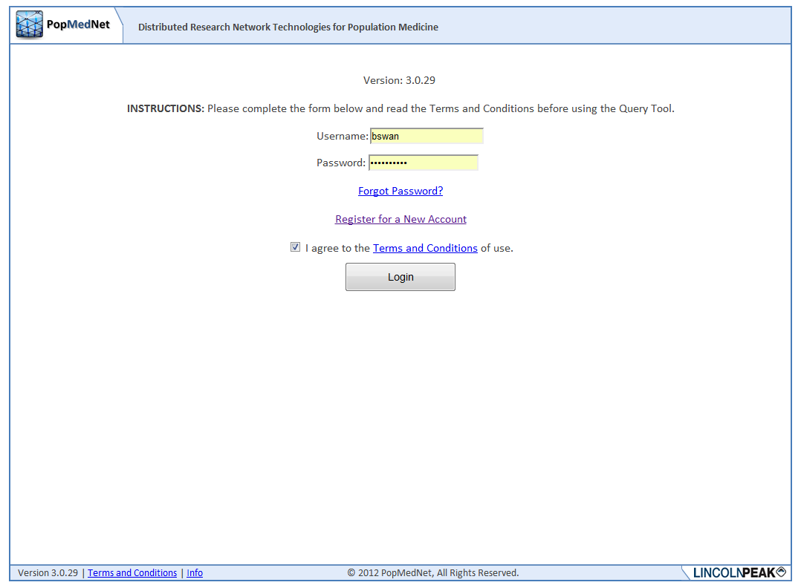

Figure 1: Logon Page

* 1. Navigate to the custom website login page:  
     [Secure URL distributed by network coordinating center]
  2. Enter your username and password in the boxes.
  3. If this is your first login, you will be prompted to read and acknowledge your agreement to the Terms and Conditions of use. If you have cookies enabled, you will not be prompted on subsequent logins.
  4. Click the Login button to enter the website Portal.

# Viewing and Releasing Results



## Checking the Query Status

You must be logged in to view the status of a query submitted to your group. Once a request is submitted and the DataMart Administrator has uploaded results, they query’s status is displayed in the Requests list as “Approval”. You may opt to receive email notifications for queries awaiting approval (see Section 5 for Email Notification Options).

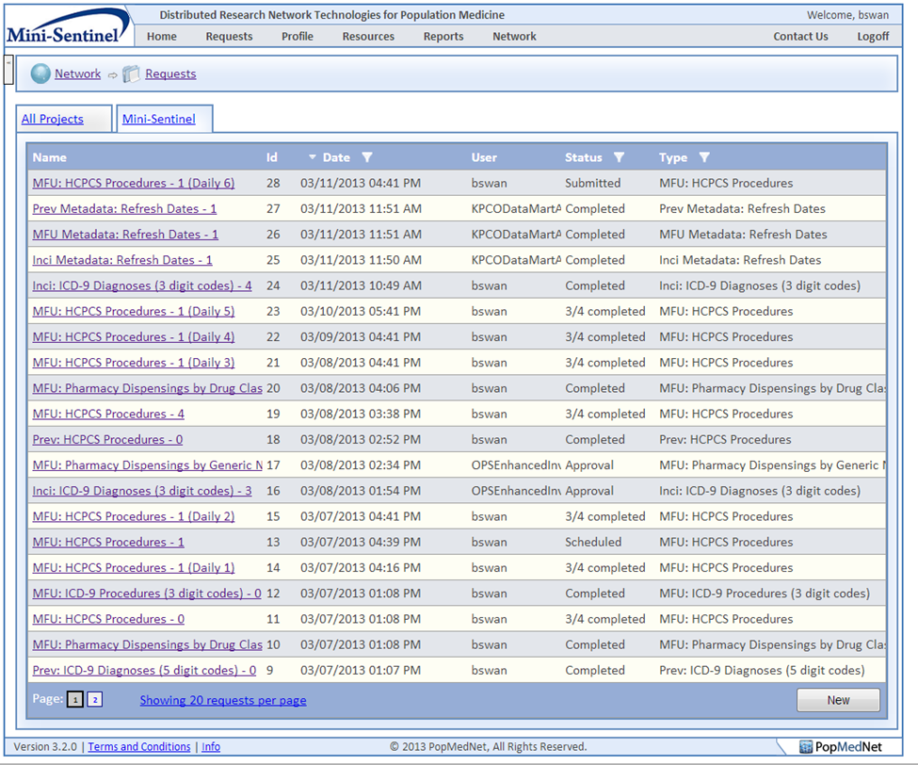

Figure 2: Request Page

## Approving Results

Once results have been uploaded by the DataMart Administrator, you will be able to view and approve results. This can be done from the request details page which is accessed by clicking on the name of a request. This page will display the descriptions and details of the query. At the bottom of the page in the Received Responses section you will have several options.

1. **View Results:** View selected results as individual or aggregate responses.
2. **Approve Responses:** Approve responses from selected DataMarts and release results to the requestor.
3. **Reject Responses:** Reject responses for selected DataMarts.
4. **Resubmit:** Ask the selected DataMart to resubmit responses to the same query.
5. **Group**: Aggregate responses from selected DataMarts and specify a name for the grouped responses.
   1. **Ungroup:** After responses have been grouped they can be ungrouped and will revert to their previous format.

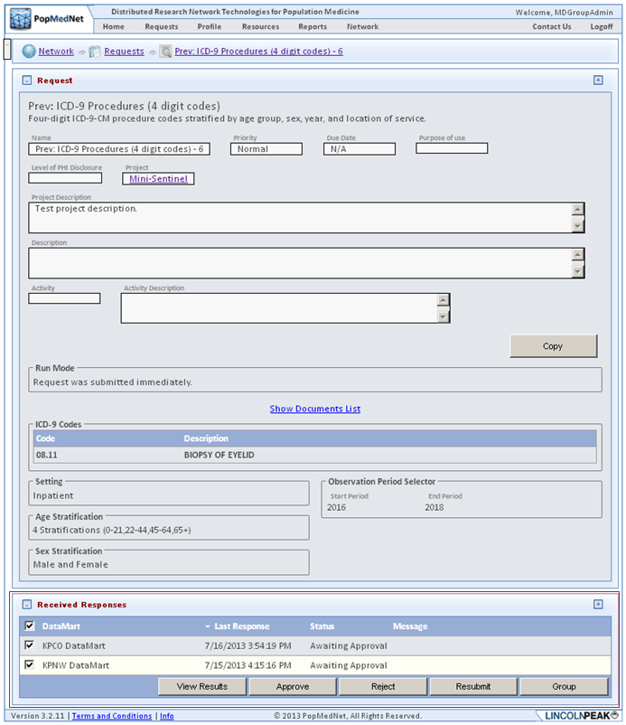

Figure 3: Request Detail Page - Received Responses Panel with Ungrouped Responses Awaiting Approval

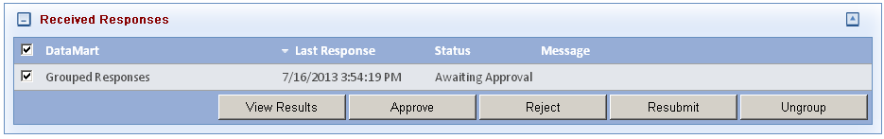

Figure 4: Request Detail Page - Received Response Panel with Grouped Responses Awaiting Approval

Selecting “View Results” will display the responses for the selected DataMarts in a table. From the Request Response Page, the following actions may be taken:

1. **Download these results**: Export the results data for the selected DataMarts to a CSV File or to Excel.
2. **Group these results:** Aggregate results from the selected DataMarts and specify a name for the grouped results.
   1. **Ungroup these results:** After results have been grouped they can be ungrouped and will revert to their previous format.
3. **Group and approve:** Aggregate results from the selected DataMarts and approve them to release results to the requestor.
4. **Approve these results:** Approve the results for the Selected DataMarts.
5. **Reject these results:** Reject the results for the selected DataMarts.

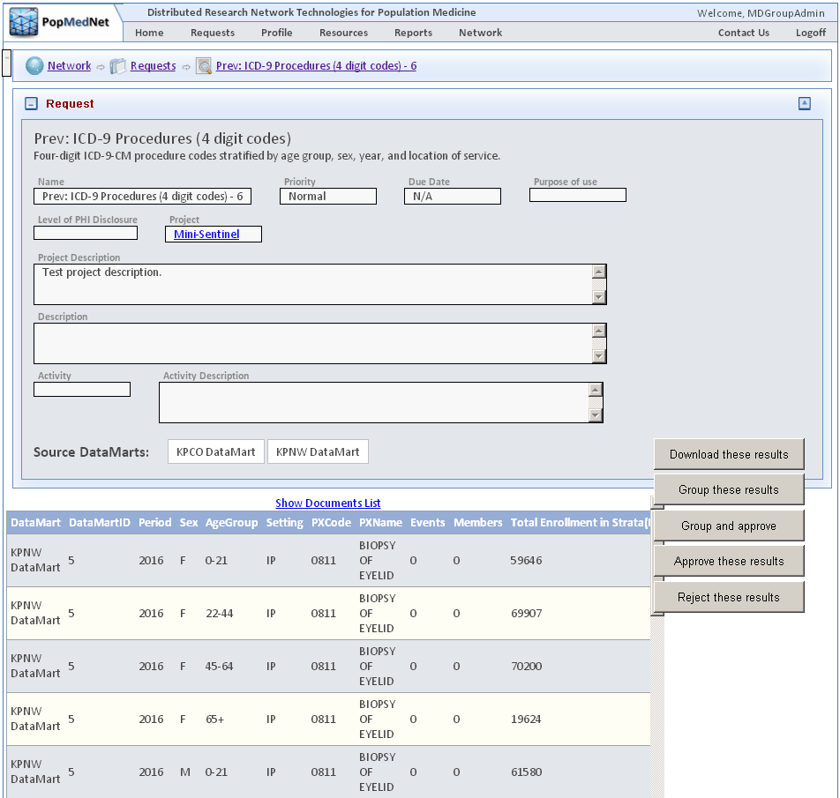

Figure 5: Request Response Page

## Calculated Rates Column

The calculated columns are included to give supporting information for the codes of interest. The Enrollment summary tables for each category are used with the corresponding selected query type to calculate the rates.

Medical Queries: HCPCS Procedures, ICD-9 Diagnoses and Procedures

* Total Enrollment in Strata (Members)-Total count includes members with both medical and drug coverage plus those with medical coverage only.
* Prevalence Rates (Users per 1000 enrollees)
* Event Rate (Events per 1000 enrollees)
* Events per Member

Drug Queries: Pharmacy Dispensings by Generic Name and Drug Class

* Total Enrollment in Strata (Members) – Total count includes members with both medical and drug coverage plus those with drug coverage only.
* Prevalence Rates (Users per 1000 enrollees)
* Dispensing Rate (Dispensings per 1000 enrollees)
* Days per Dispensing
* Days per User

# Administering or Changing your User Profile

This section describes how to administer your user profile. You must be logged in to the web Portal to administer your user profile. Click Profile menu to view your account information.



## Screenshot of the contact information panel on a user profile page on the portalContact Information

You can enter or update your information in the Contact Information panel.

Figure 6: User Contact Information Panel

## Security Group Membership

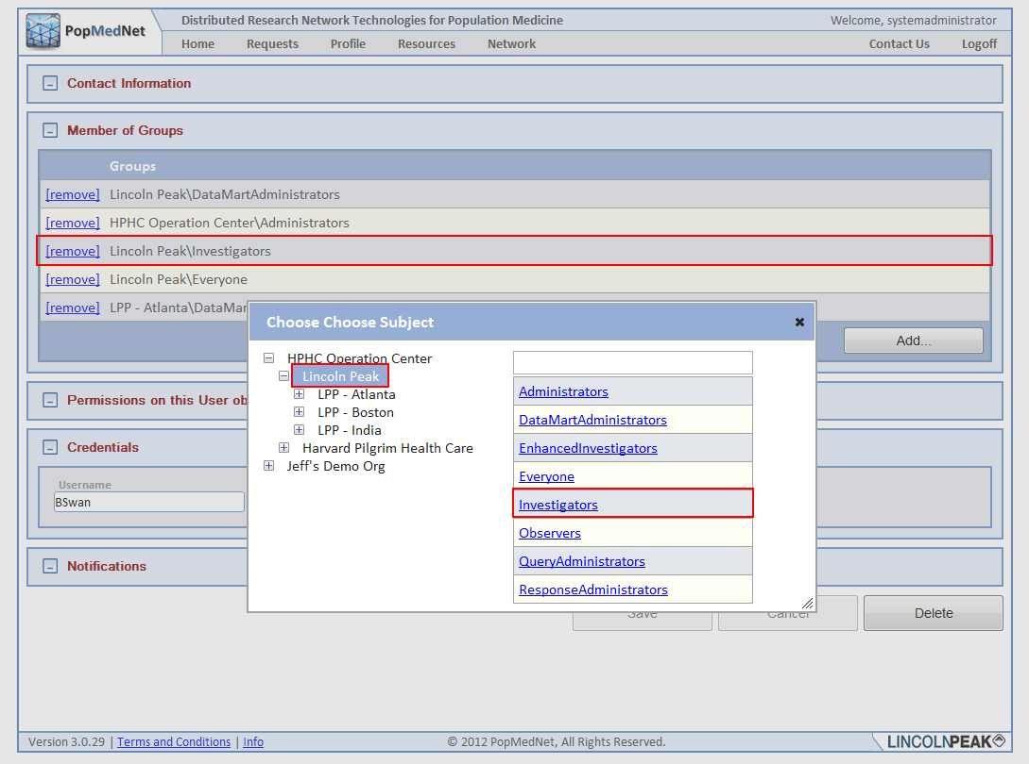Users belong to a single organization, but can take on multiple roles through membership in Security Groups. Administrators with access rights to manage user access control may select one or more security groups for which the user is a member. Membership grants the user all the rights in each security group. The following figure illustrates a list of groups the user is a member of along with the dialog used to add membership into existing groups.

Figure 7: User Membership Panel

Typically, users do not have the access rights to modify their own security profile. This right is intended for either site-wide “Root” administrators or administrators who are members of the user’s organization.

## Changing your Password

The user credentials consist of a Username and Password. The username must be unique across the network. The password must be at least 9 characters long and consist of at least one number, one symbol, and at least one upper case character. Users always have the rights to modify their password at any time. Password expire periodically base on a network-wide settings described in the Network Configuration section below.

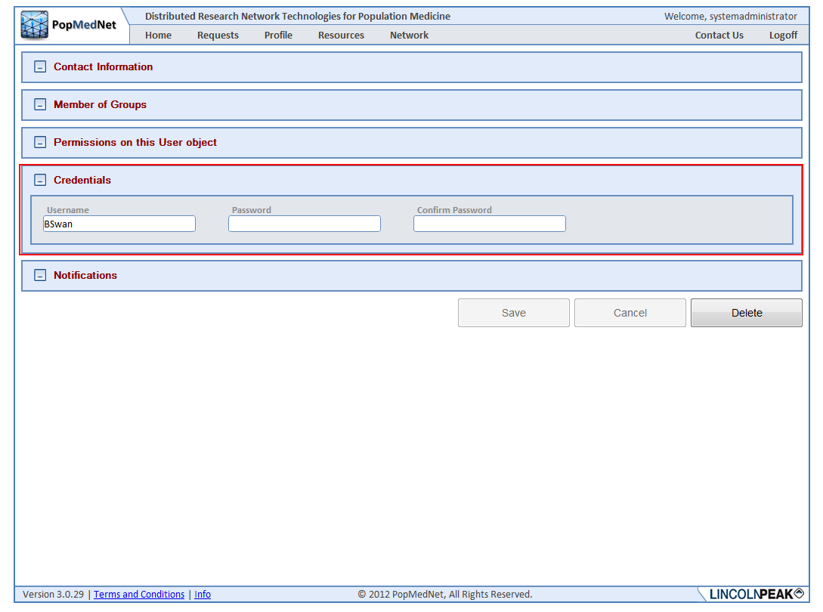**Figure 8: User Credentials Panel**

## Receiving Notifications

Notification options allow the user to manage events that are triggered due to actions performed by the user or related to the user’s role, such as a DataMart Administrator. Users have the option of receiving notifications immediately when they are triggered, daily, weekly, or monthly. When choosing daily, weekly, or monthly, the notifications are batched together with other notifications on the same schedule in a single email.

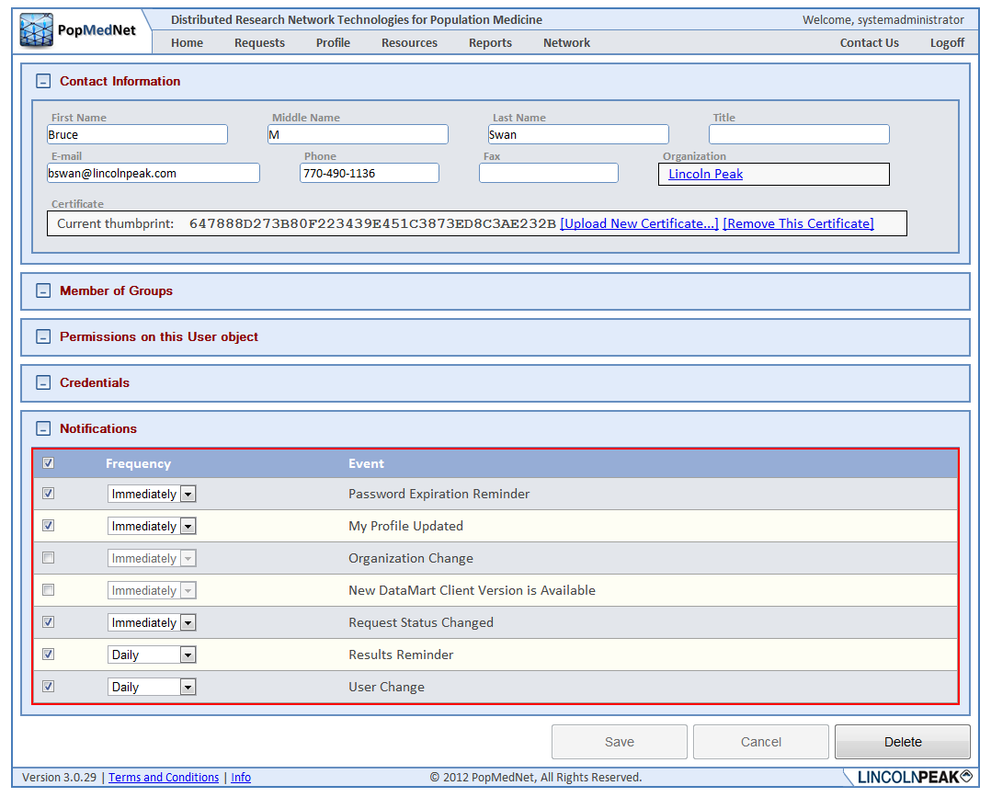

Figure 9: User Notifications Panel

***Note:*** *Once the user has chosen to receive notifications, no matter what the delivery frequency is selected; the notifications are displayed in the Notifications panel on the Home page.*

### Notification Event Reference

The following table lists each event that may be created in PopMedNet™ along with a description.

Table 2: Notifications

| Category | Event | Description |
| --- | --- | --- |
| User | Password Expiration Reminder | Notifies users when their password will be expiring |
|  | My Profile Change | Notifies you when your user profile has changed |
|  | User Change | Notifies you when a user has updated his/her user profile |
|  | New User Registration Submitted | Notifies you when a new user submits their registration form for network access |
|  | Registration Change | Notifies you when the registration status of a new user changes |
| Requests | New Request Submitted | Notifies you when a new request has been submitted to your DataMart and requires your action to process it |
|  | Request Status Changed | Notifies you when your submitted request has been on placed on hold or rejected by the DataMart administrator that you submitted the query to. |
|  | Request Reminder | Notifies you when a previously submitted request is still pending and requires your attention in order to process it |
|  | Results Reminder | Notifies you when the DataMart administrator has accepted your query and the query results have been uploaded. |
|  | Results Viewed | Notifies the DataMart Administrator when results are viewed on the Portal |
|  |  |  |
| Organization | Organization Change | Notifies you when an Organization has been added or deleted to the list of organizations that can send Queries to your DataMart |
|  |  |  |
| Group | Group Change | Notifies you when a group has been added or deleted to the list of groups allowed to send queries to your DataMart |
|  |  |  |
| DataMart | New DataMart Client Version is Available | For Datamart Administrators: Email notifications are sent to the DataMart Administrators. It alerts these administrators that the new version of the DataMart Client application is available for download. |
|  | DataMart Change | Notifies you when a DataMart has been added or deleted to the list of groups allowed to send queries to your DataMart |

# Getting Help

Once logged in, the Resource Tab offers helpful contact information, documentation, and related links, as seen below.

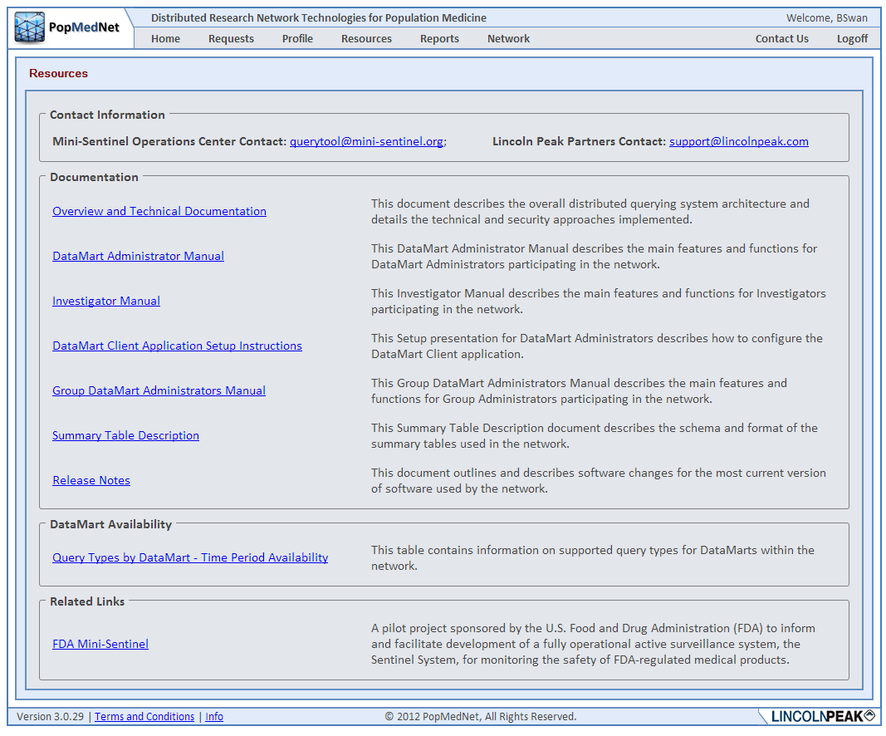

Figure 10: Resources Page

If you have trouble accessing the Web Portal or your user account, click on the Contact Us link and describe your issue in the email. To request additional help, contact your Network Administrator or the PopMedNet™ support staff directly.

# Development and Funding Statement

The **PopMedNet™** software application was developed as part of several contracts awarded by the Agency for Healthcare Research and Quality (AHRQ) to the HMO Research Network (HMORN) Center for Education and Research on Therapeutics (CERT) DEcIDE Center housed in the Department of Population Medicine at the Harvard Pilgrim Health Care Institute (HPHCI). Additional development was funded by AHRQ under the Scalable PArtnering Network for CER: Across Lifespan, Conditions, and Settings (SPAN) project. Additional support has been provided by The Food and Drug Administration’s Mini-Sentinel project (Contract No. HHSF223200910006I) and the US Department of Health and Human Services’ Office of the National Coordinator for Health Information Technology (ONC) MDPHnet project.

The system was developed by Lincoln Peak Partners under the direction of HPHCI.

PopMedNet™ can accommodate a wide scope of network sizes and complexity, ranging from single datasets held by only two organizations through multi-year projects encompassing dozens of organizations and dozens of data resources. Networks powered by the PopMedNet™ application can customize and brand the network as desired. The Department of Population Medicine at the Harvard Pilgrim Health Care Institute (HPHCI) led development of the system in collaboration with Lincoln Peak Partners (LPP). Lincoln Peak Partners provides support services and secure hosting for current system users, and leads development of system enhancements.

# Frequently Asked Questions

This section lists some of the most frequently asked questions.

What is the difference between Groups, Organizations, and Users?

A user is a person who has login credentials to the network Portal. Users are associated with one Organization. Organizations can be associated with one or more Groups. A Group is a set of network Organizations and can only be created by the Network Administrator. A user is typically associated with their employer organization. Organizations can be Data Partners (for example, Kaiser Permanente Colorado), federal agencies (for example, FDA, NIH), or affiliated institutions such as academic medical centers.

Users are individuals with various security groups and associated rights within the network.

What are my rights as a user and how can I change them?

Rights are mainly assigned by the Network Administrator(s). The Network Administrators can also allow certain users to assign rights within an organization or group based on the governance of the network.

Where can I get more information on the PopMedNetTM?

You may contact the Operations Center for more information:

Jeffrey Brown, PhD

Harvard Pilgrim Health Care Institute

[Jeff_brown@hphc.org](mailto:Jeff_brown@hphc.org)

[www.popmednet.org](http://www.popmednet.org)